**DAILY ONLINE ACTIVITIES SUMMARY**

|  |  |  |  |  |  |  |  |  |
| --- | --- | --- | --- | --- | --- | --- | --- | --- |
| **Date:** | **05-06-2020** | | | | | **Name:** | **Preethi** | |
| **Sem & Sec** | **6th - B** | | | | | **USN:** | **4AL17CS065** | |
| **Online Test Summary** | | | | | | | | |
| **Subject** | | **Operation Research** | | | | | | |
| **Max. Marks** | | **30** | | **Score** | | | **30** | |
| **Certification Course Summary** | | | | | | | | |
| **Course** | **Introduction to Cloud Computing** | | | | | | | |
| **Certificate Provider** | | | **Cognitive Class-IBM**  **DeveloperSkillsNetwork** | | **Duration** | | | **10 hours** |
| **Coding Challenges** | | | | | | | | |
| **Problem Statement:1 Python and 1 java program** | | | | | | | | |
| **Status: executed** | | | | | | | | |
| **Uploaded the report in GitHub** | | | | | **Yes** | | | |
| **If yes Repository name** | | | | | <https://github.com/PreethiNayak/Daily-Status/tree/master/05June2020> | | | |
| **Uploaded the report in slack** | | | | | **Yes** | | | |

Online Test Details: (Attach the snapshot and briefly write the report for the same)

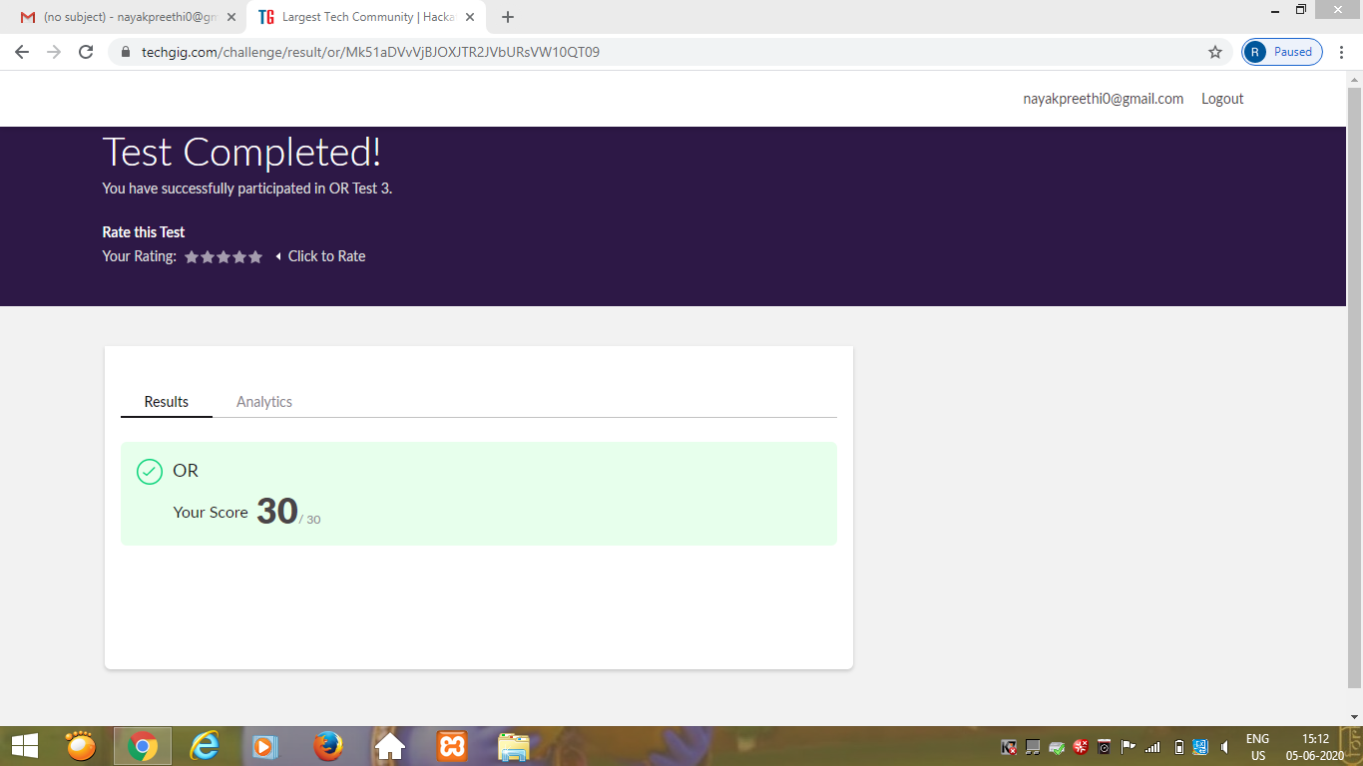

Certification Course Details: (Attach the snapshot and briefly write the report for the same)

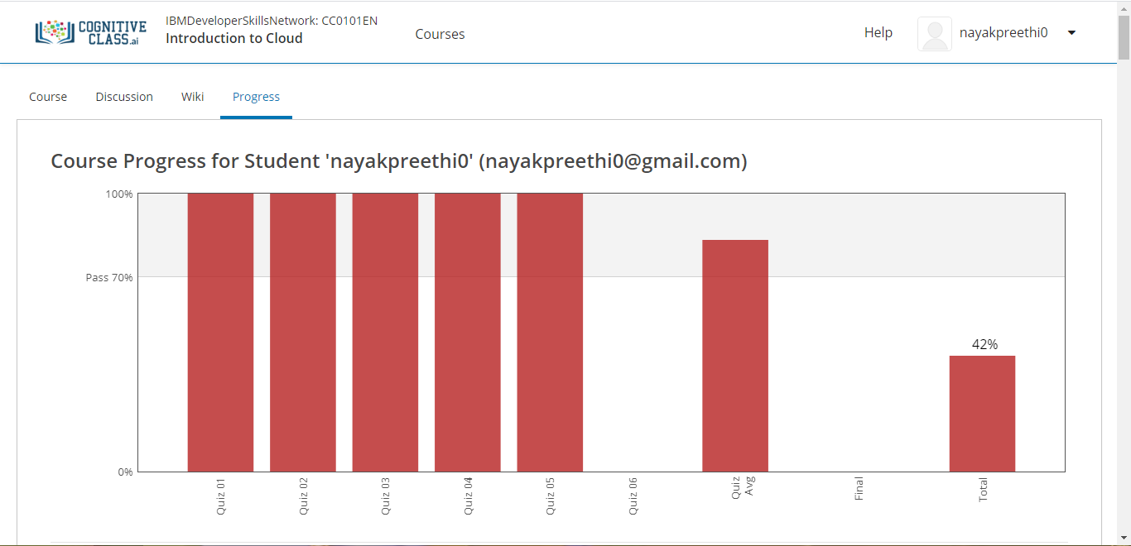

Today I completed module 5 –“Cloud Computing storage and Content Delivery Networks”

In this I learnt,

1. Basics of Cloud Storage(File storage,Block storage,Object storage).

2.Tiers and APIs of Object Storage.

3. Content Delivery Networks.

4.Create an Object storage Instance and add items.

Coding Challenges Details: (Attach the snapshot and briefly write the report for the same)

Program 1

This is output of java program to implement Circular Linked list using array and Class.

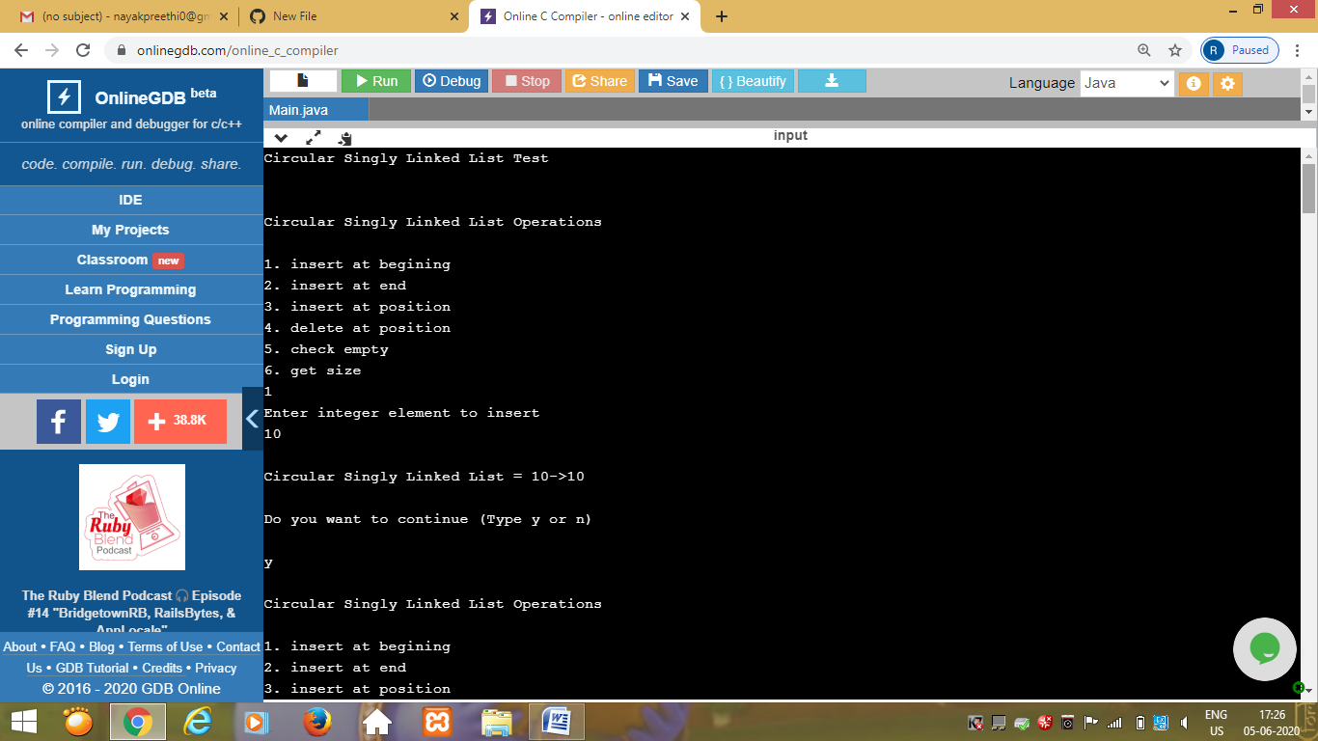

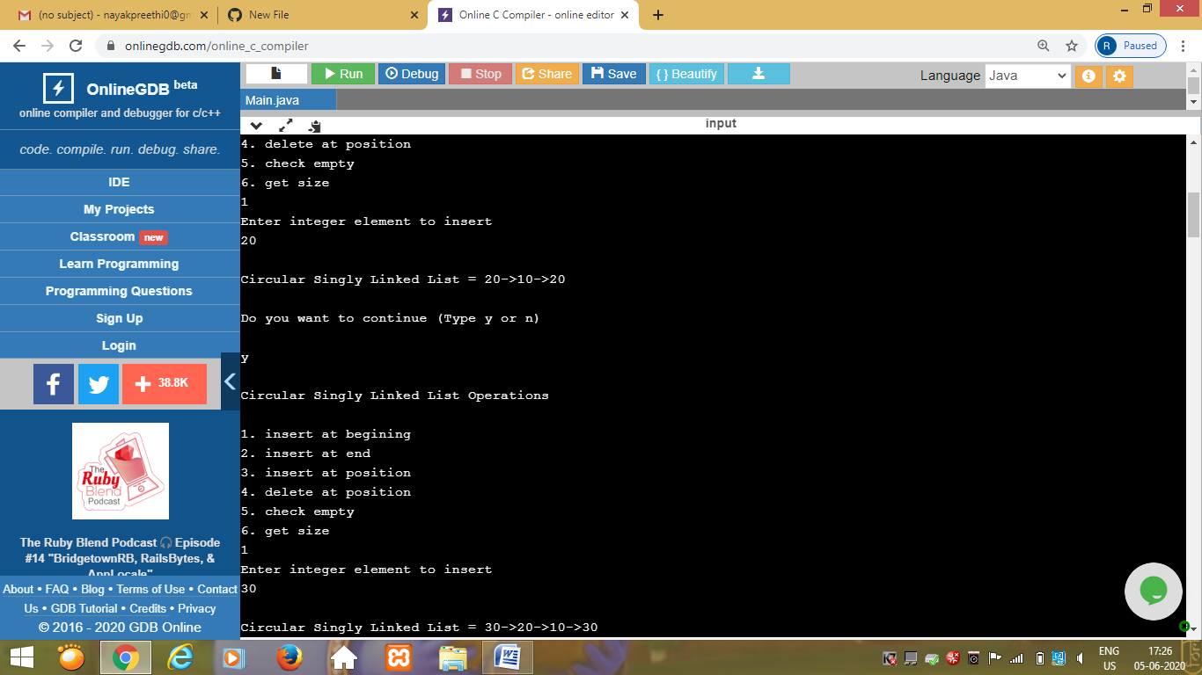

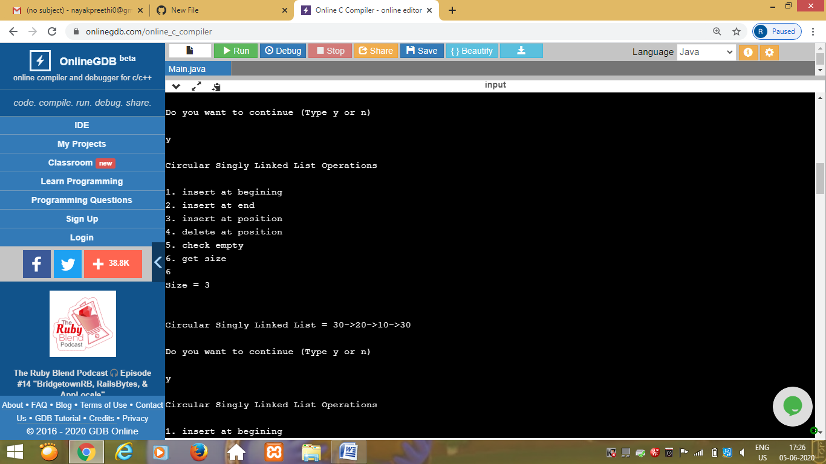

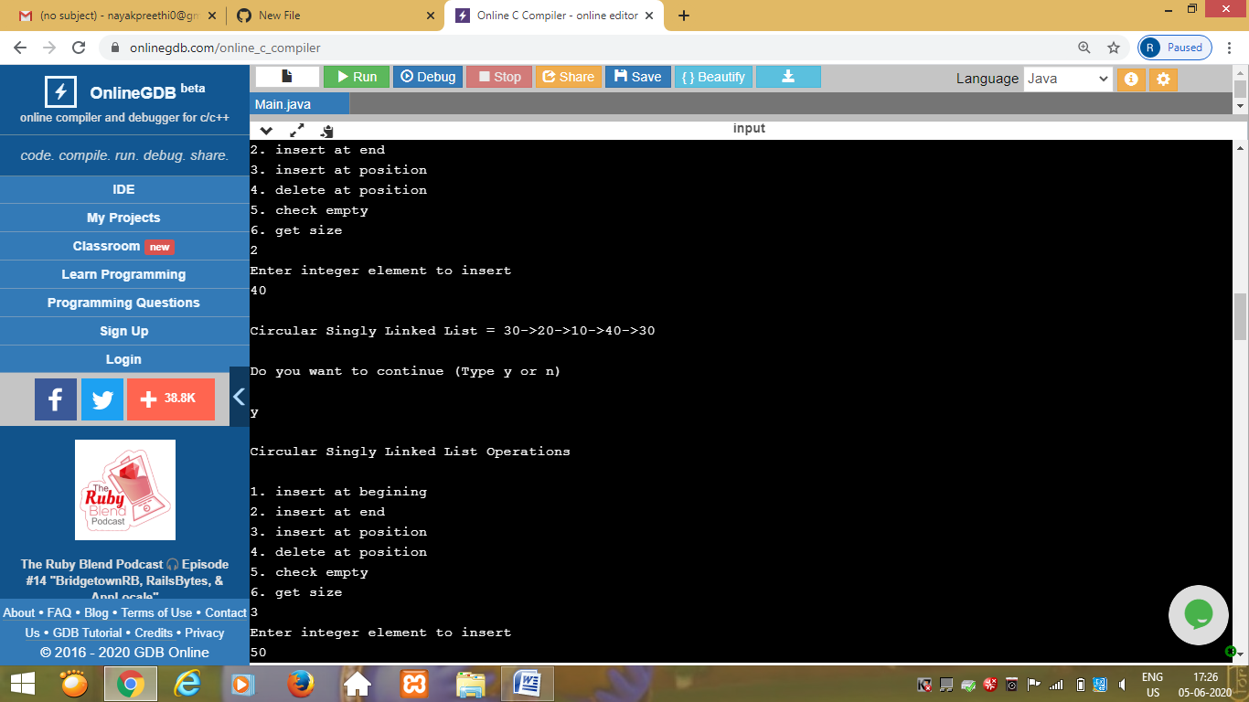

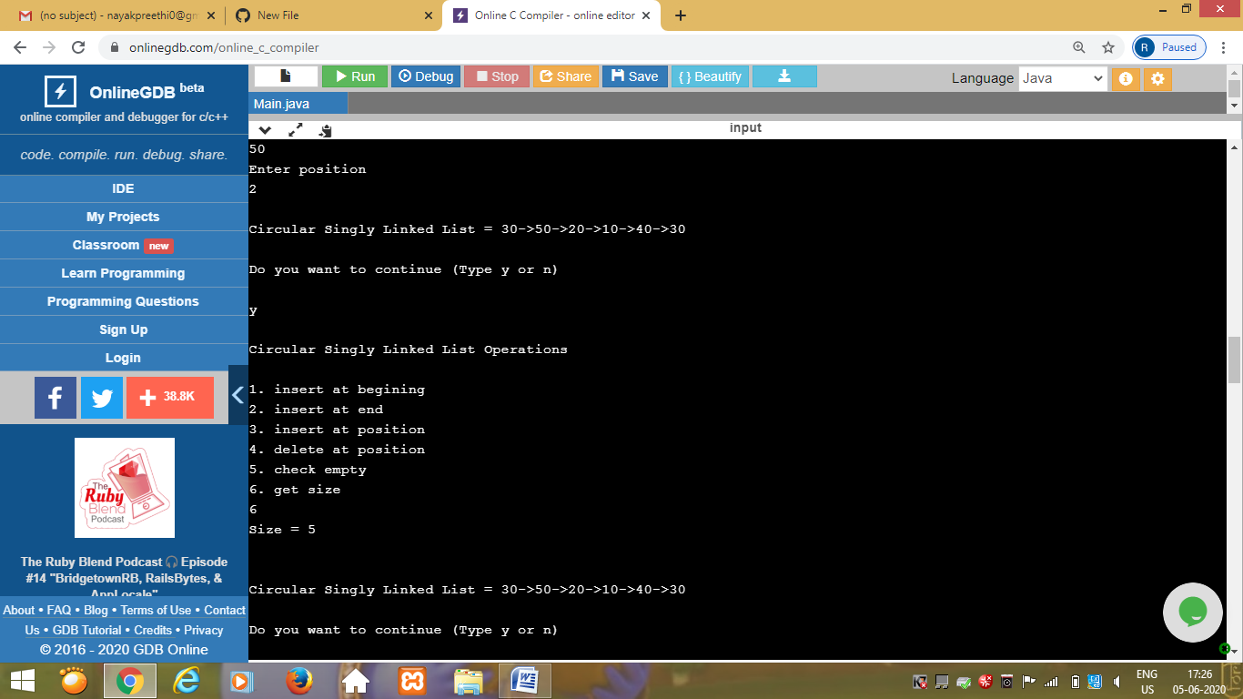

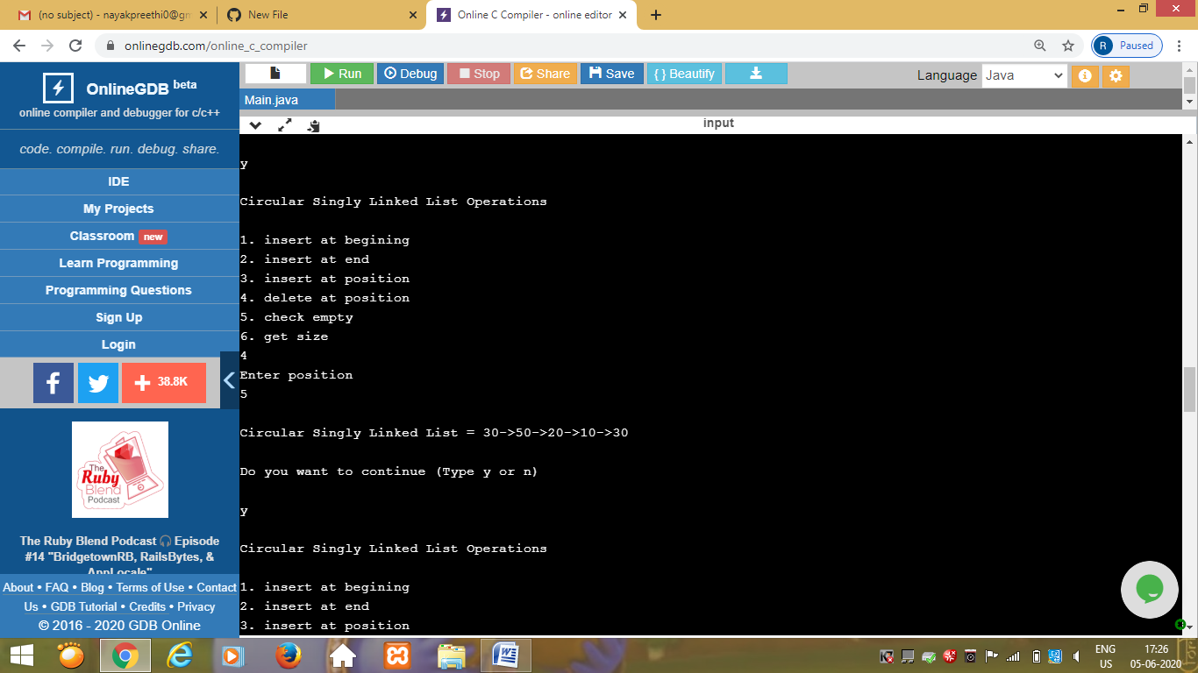

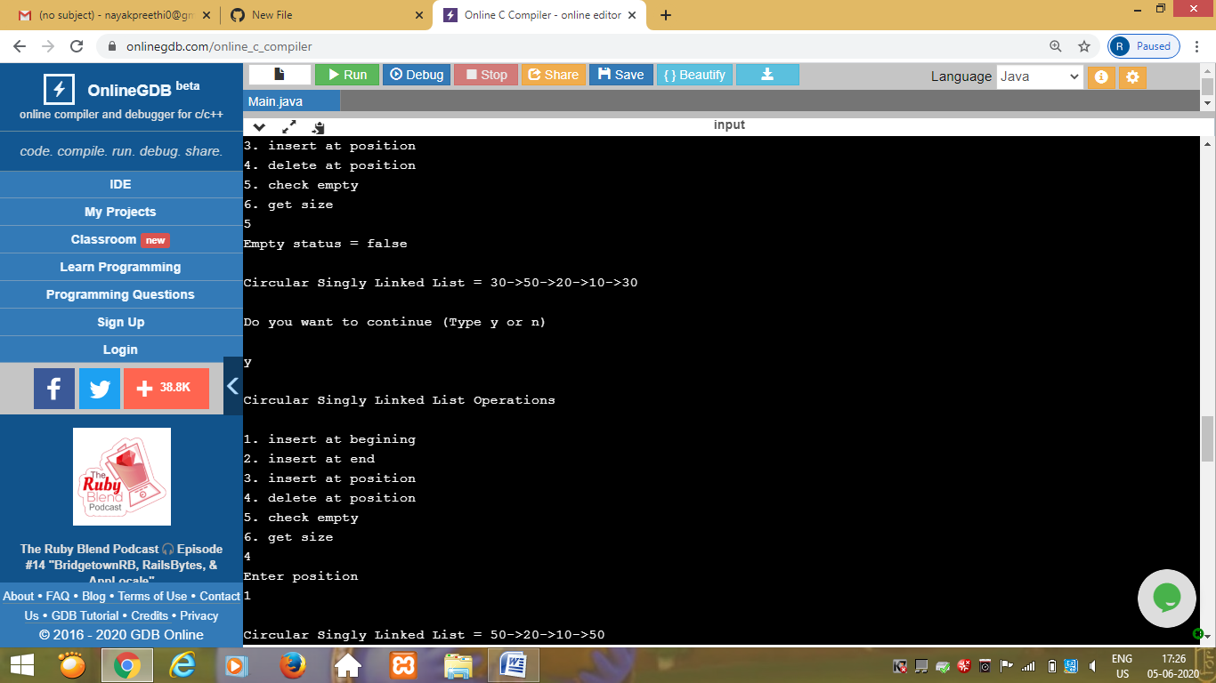

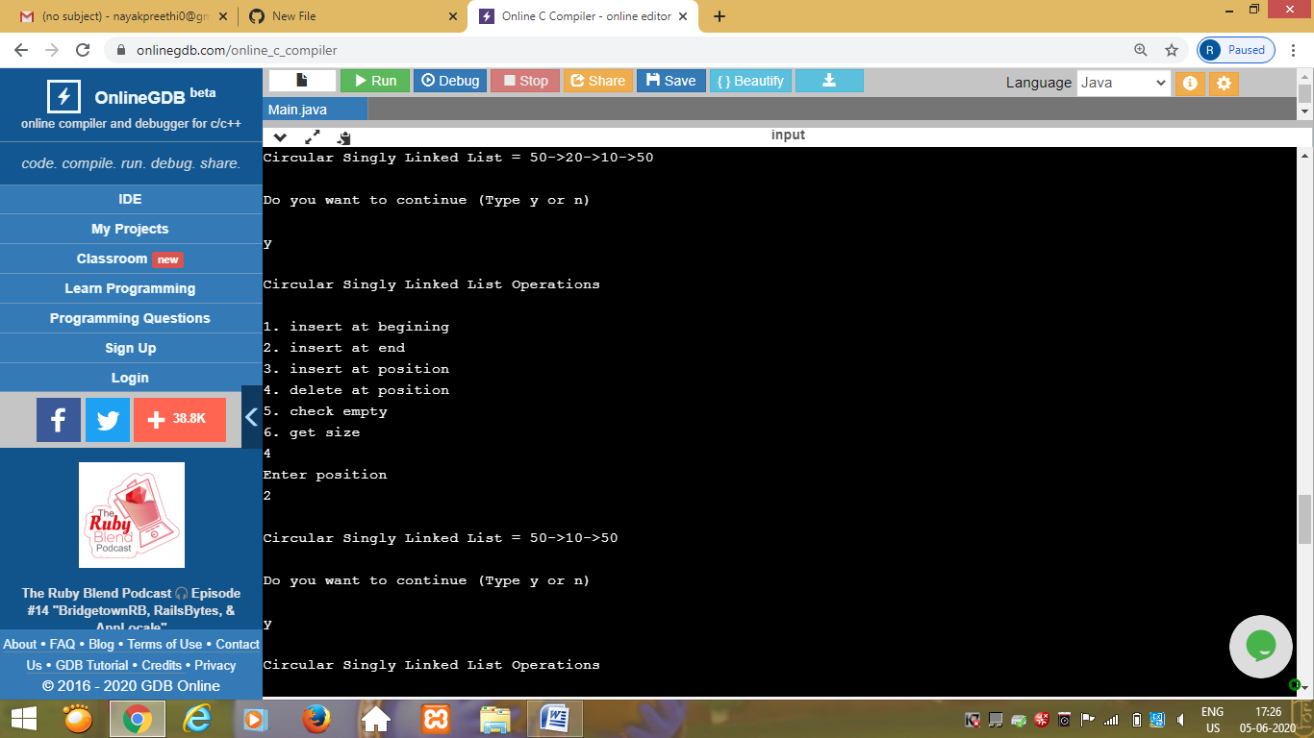

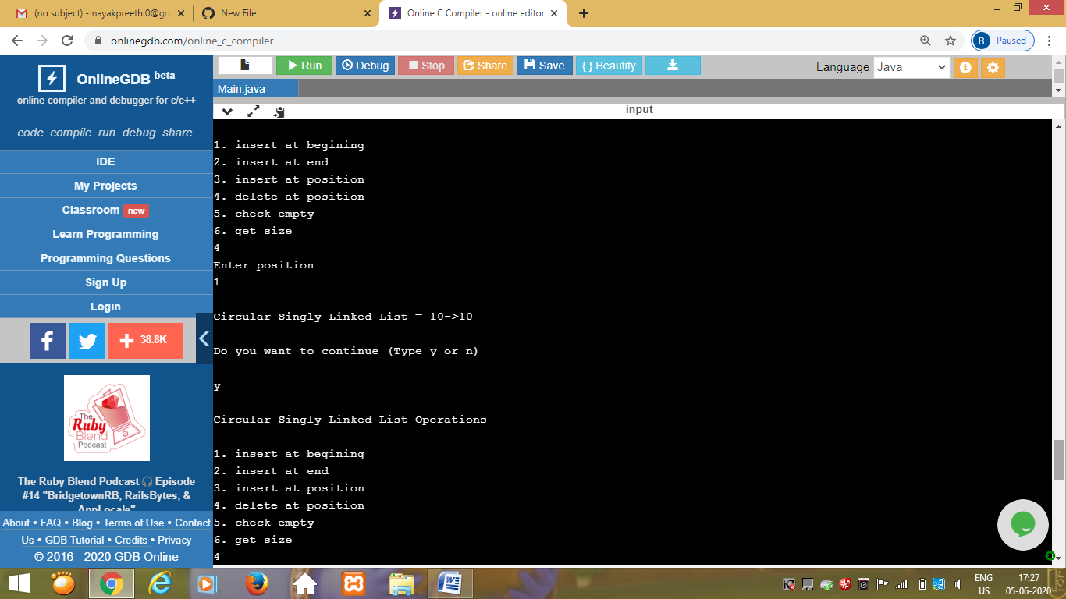

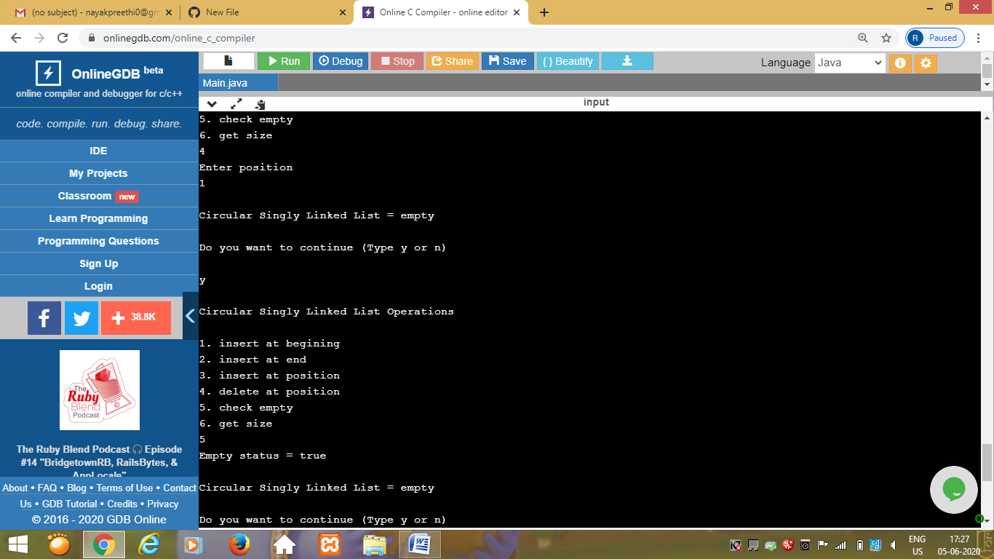

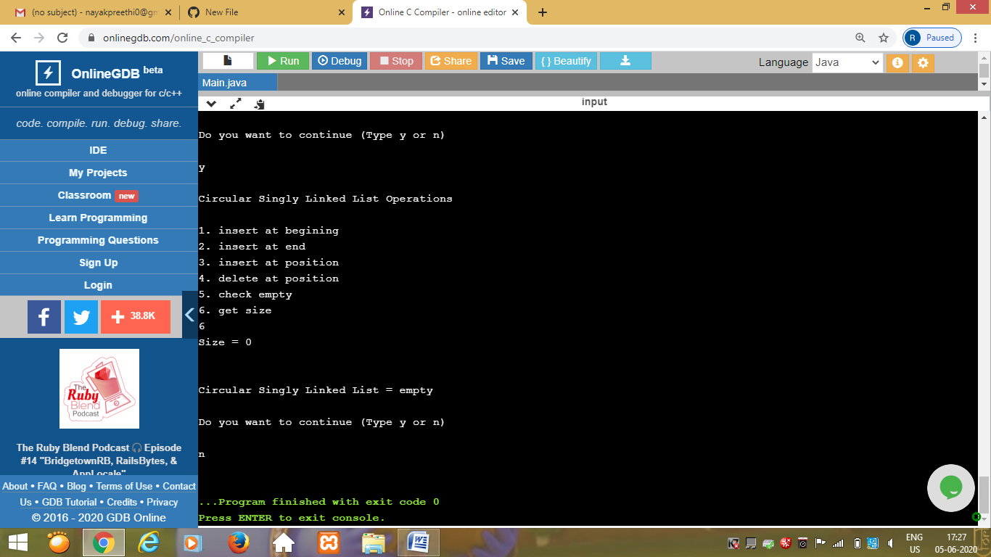

Program 2

This is the output of the python program to square each odd number in the list.

